
SCHOOL OF COMPUTING AND INFORMATICS
BACHELOR OF SCIENCE IN INFORMATION TECHNOLOGY
UNITE TITLE: ADVANCED WEB DESIGN AND DEVELOPMENT
UNITE CODE: BIT3208
PROJECT TITLE: Retail ERP system
Name : Mohamed Deq Hassan
REG. NO: BSCCS/2024/56873
SUPERVISOR: MR. MICHAEL NYORO

Table of Contents
1.0 INSTALLATION LOCALHOST TOOL 3
1.1 XAMPP 3
1.2 Tested localhost successfully 3
1.3 Created Hello World pages 4
1.4 Tested basic database connectivity 4
2.0 Website Design and Project Planning 4
2.1 Designed GUI Layouts 4
2.2 Planned Project Workflow 4
2.3 Selected Technologies 5
3.0 Retail POS SYSTEM REPORT 5
3.1 Home Page 5
3.2 Dashboard 6
4.0 INVENTORY MANAGEMENT(CRUD) 6
4.1 Stock Inventory Page 7
4.2 CRUD OPERATIONS 7
4.3 Add Item 8
4.4 Delete function 8
4.5 Update 9
5.0 SALES MANAGEMENT 9
5.1 Record New Sale 9
5.2 Sales Records 10
6.0 DATABASE AND GITHUB 11
6.1 Database Integration 11
6.2 phpMyAdmin Database Table 12
6.3 Database connection code 12
6.4 GitHub Version Control 12
6.5 GitHub Repository System 13
7.0 CONCLUSION 13

1.0 INSTALLATION LOCALHOST TOOL

1.1 XAMPP
XAMPP was installed successfully to create a local server environment for web development. Apache and MySQL services were included to help run websites and manage databases on the computer.
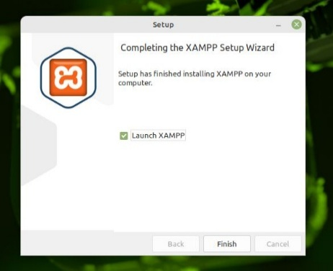

1.2 Tested localhost successfully
The localhost was tested by opening http://localhost in the browser. The XAMPP dashboard appeared successfully, showing that the Apache server was running correctly and the local environment was ready for web development.

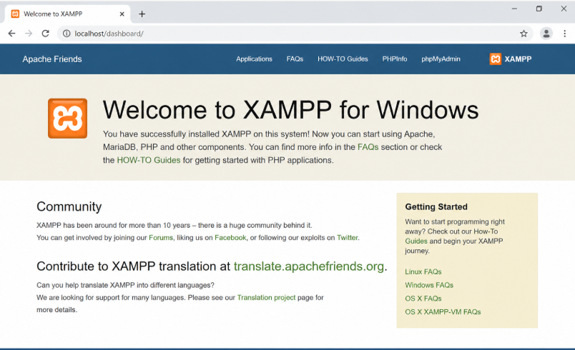

1.3 Created Hello World pages
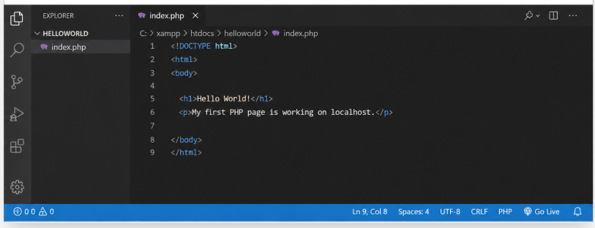
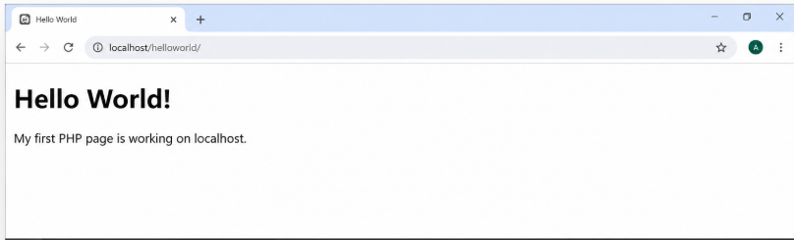

1.4 Tested basic database connectivity
A database connection test was performed using PHP and MySQL. The successful connection message confirmed that the web application could communicate properly with the database server.
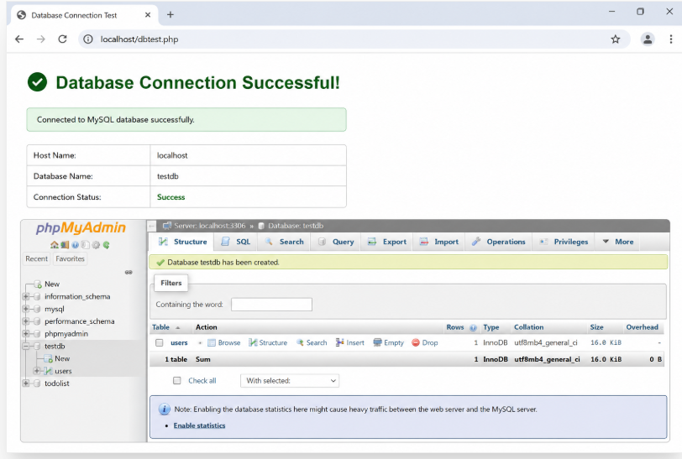

2.0 Website Design and Project Planning

2.1 Designed GUI Layouts
User interface designs were created to show how the web pages would look and function.
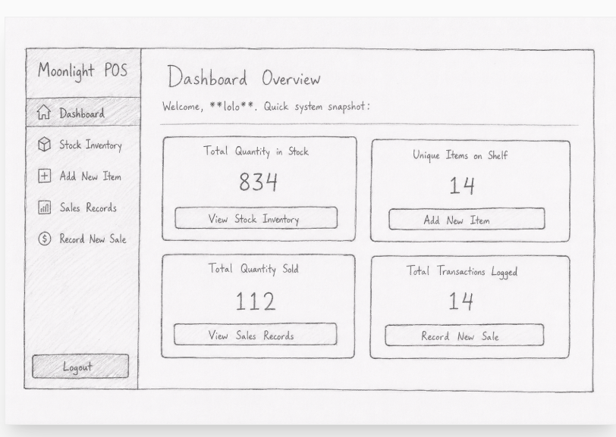

2.2 Planned Project Workflow
The steps and activities of the project were organized to ensure smooth development.
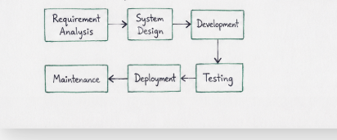

2.3 Selected Technologies
Appropriate tools and technologies such as HTML, CSS, PHP, MySQL, and XAMPP were chosen for the project development.

3.0 Retail POS SYSTEM REPORT
This system is a web-based point of sale and Inventory Management System developed using PHP, MySQL, HTML, CSS and JavaScript. The system manages inventory, sales records and transaction tracking.

3.1 Home Page
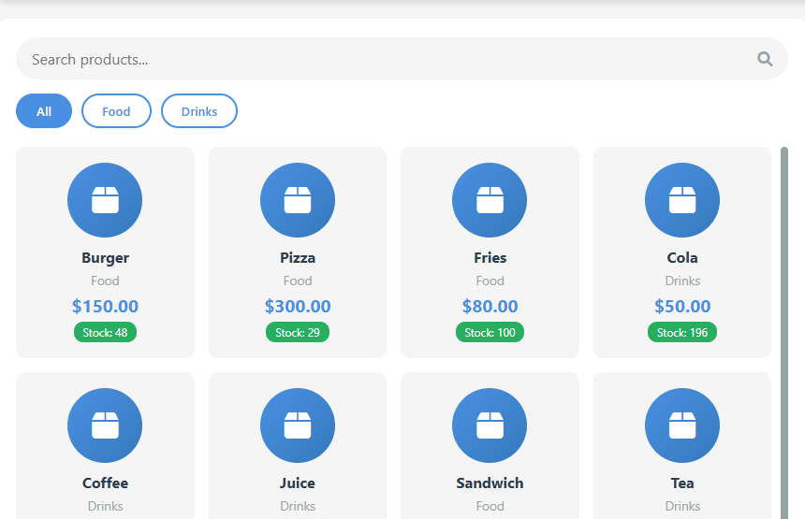

3.2 Dashboard
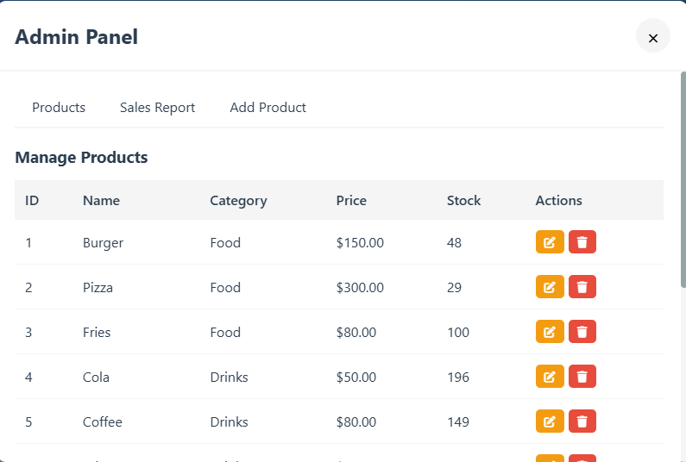

4.0 INVENTORY MANAGEMENT(CRUD)
Inventory Module
The inventory section stores and manages product information such as item name, category, stock, ID and pricing details.

4.1 Stock Inventory Page
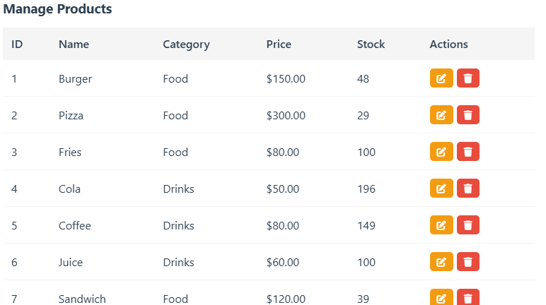

4.2 CRUD OPERATIONS
The system implements CRUD operations:
- Create -add new products.
- Read -view inventory records.
- Update -edit product information.
- Delete -remove unwanted records.

4.3 Add Item
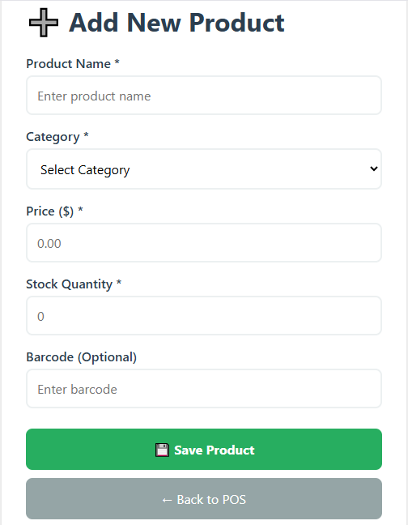

4.4 Delete function


The actions include delete which allows one to delete a certain item

4.5 Update

The actions include update which allows one to update a certain item

5.0 SALES MANAGEMENT

5.1 Record New Sale
The sales module allows users to record complete sales transactions into the system database.
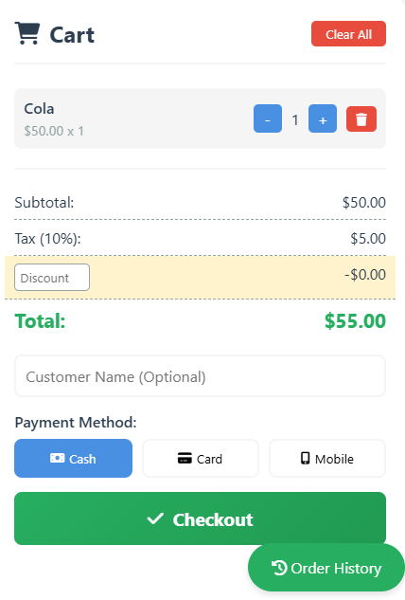

5.2 Sales Records
The system displays transaction history including quantity sold, sale amount, date and salesperson information.
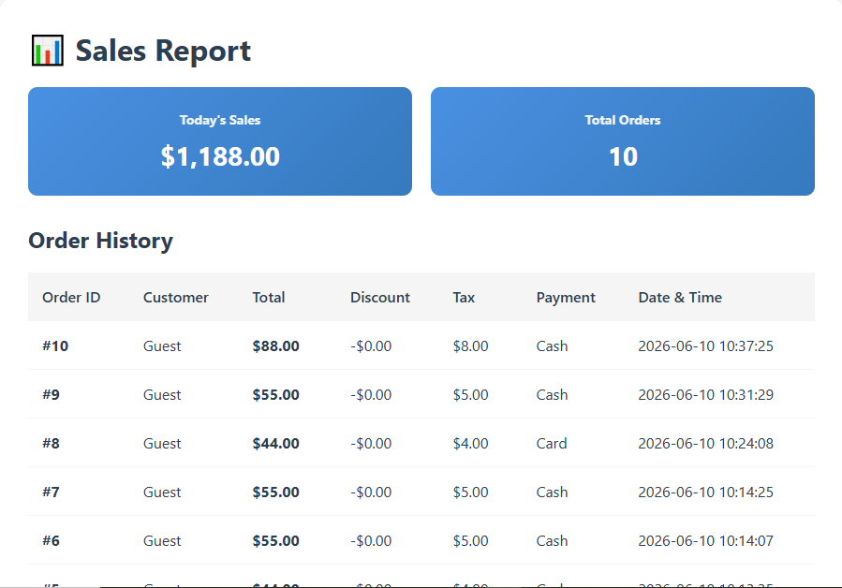

6.0 DATABASE AND GITHUB

6.1 Database Integration
The system uses PHP and MySQL database connection to store, retrieve, update and manage data dynamically.

6.2 phpMyAdmin Database Table
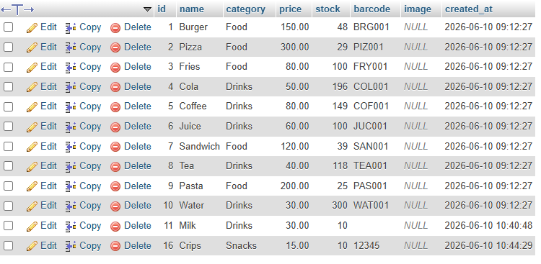

6.3 Database connection code
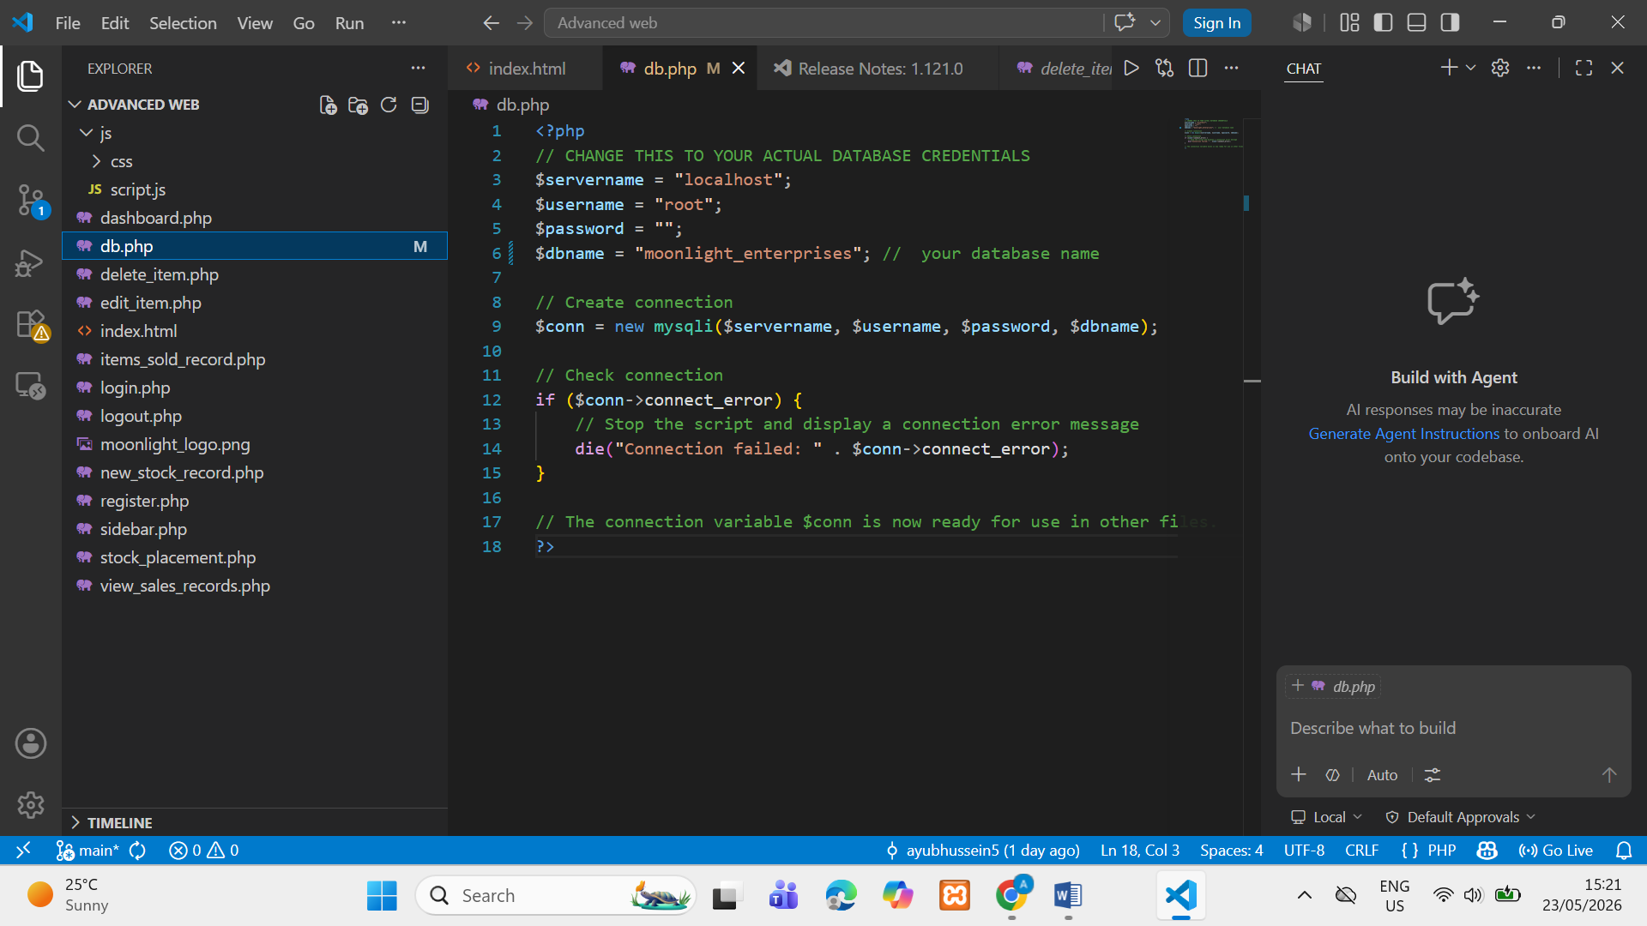

6.4 GitHub Version Control
GitHub was used to save project progress, maintain backups and track development updates.

6.5 GitHub Repository System
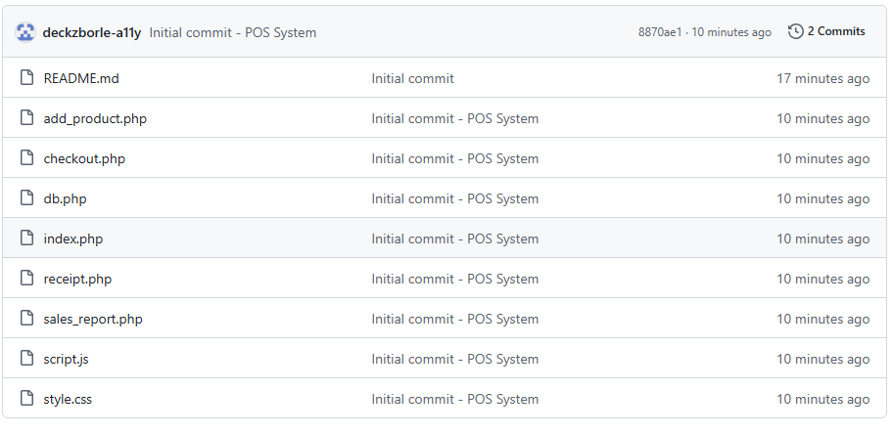

https://github.com/deckzborle-a11y/pos-system.git

7.0 CONCLUSION
This system successfully demonstrates backend development, database integration, authentication, inventory management, sales processing and CRUD operations.

